1. Which are the top three variables in your model which contribute most towards the probability of a lead getting converted?

Answer:-

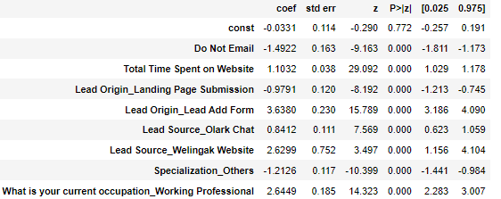

Based on the final model coefficients value as shown above the top 3 variables are:-

1) Lead Origin.

2) Lead Source.

3) What is your current Occupation

2. What are the top 3 categorical/dummy variables in the model which should be focused the most on in order to increase the probability of lead conversion?

**Answer:-** 

The Top3 Dummy variable according to the above mentioned screen shots of final model are:

1) Lead Origin_Lead Add form

2) Lead Source_ Welingak Website

3) What is your current Occupation_ Working Professional

3. X Education has a period of 2 months every year during which they hire some interns. The sales team, in particular, has around 10 interns allotted to them. So during this phase, they wish to make the lead conversion more aggressive. So they want almost all of the potential leads (i.e. the customers who have been predicted as 1 by the model) to be converted and hence, want to make phone calls to as much of such people as possible. Suggest a good strategy they should employ at this stage.

**Answer:-**As per the final model the optimal Probability considered for the lead conversion is 0.3%. If X Education wants to make their lead conversion more aggressive they can consider a probability value of 0.2% which will give them all the leads which are predicted as 1 by model. It will also give then some additional leads as well.

4. Similarly, at times, the company reaches its target for a quarter before the deadline. During this time, the company wants the sales team to focus on some new work as well. So during this time, the company’s aim is to not make phone calls unless it’s extremely necessary, i.e. they want to minimize the rate of useless phone calls. Suggest a strategy they should employ at this stage.

**Answer: -** For the times when company reaches its target for a quarter before the deadline. And company wants the sales team to focus on some new work as well. During this time the company can switch to 0.5% as the optimal probability for model building this will give them only necessary leads only. But it will have a disadvantage that it will sometimes lead to miss out some of the leads. But this should not cause issue as the target has already been achieved.